Stage 3 – Bonnie Blue
COURSE DESIGNER: Rocky Perillo

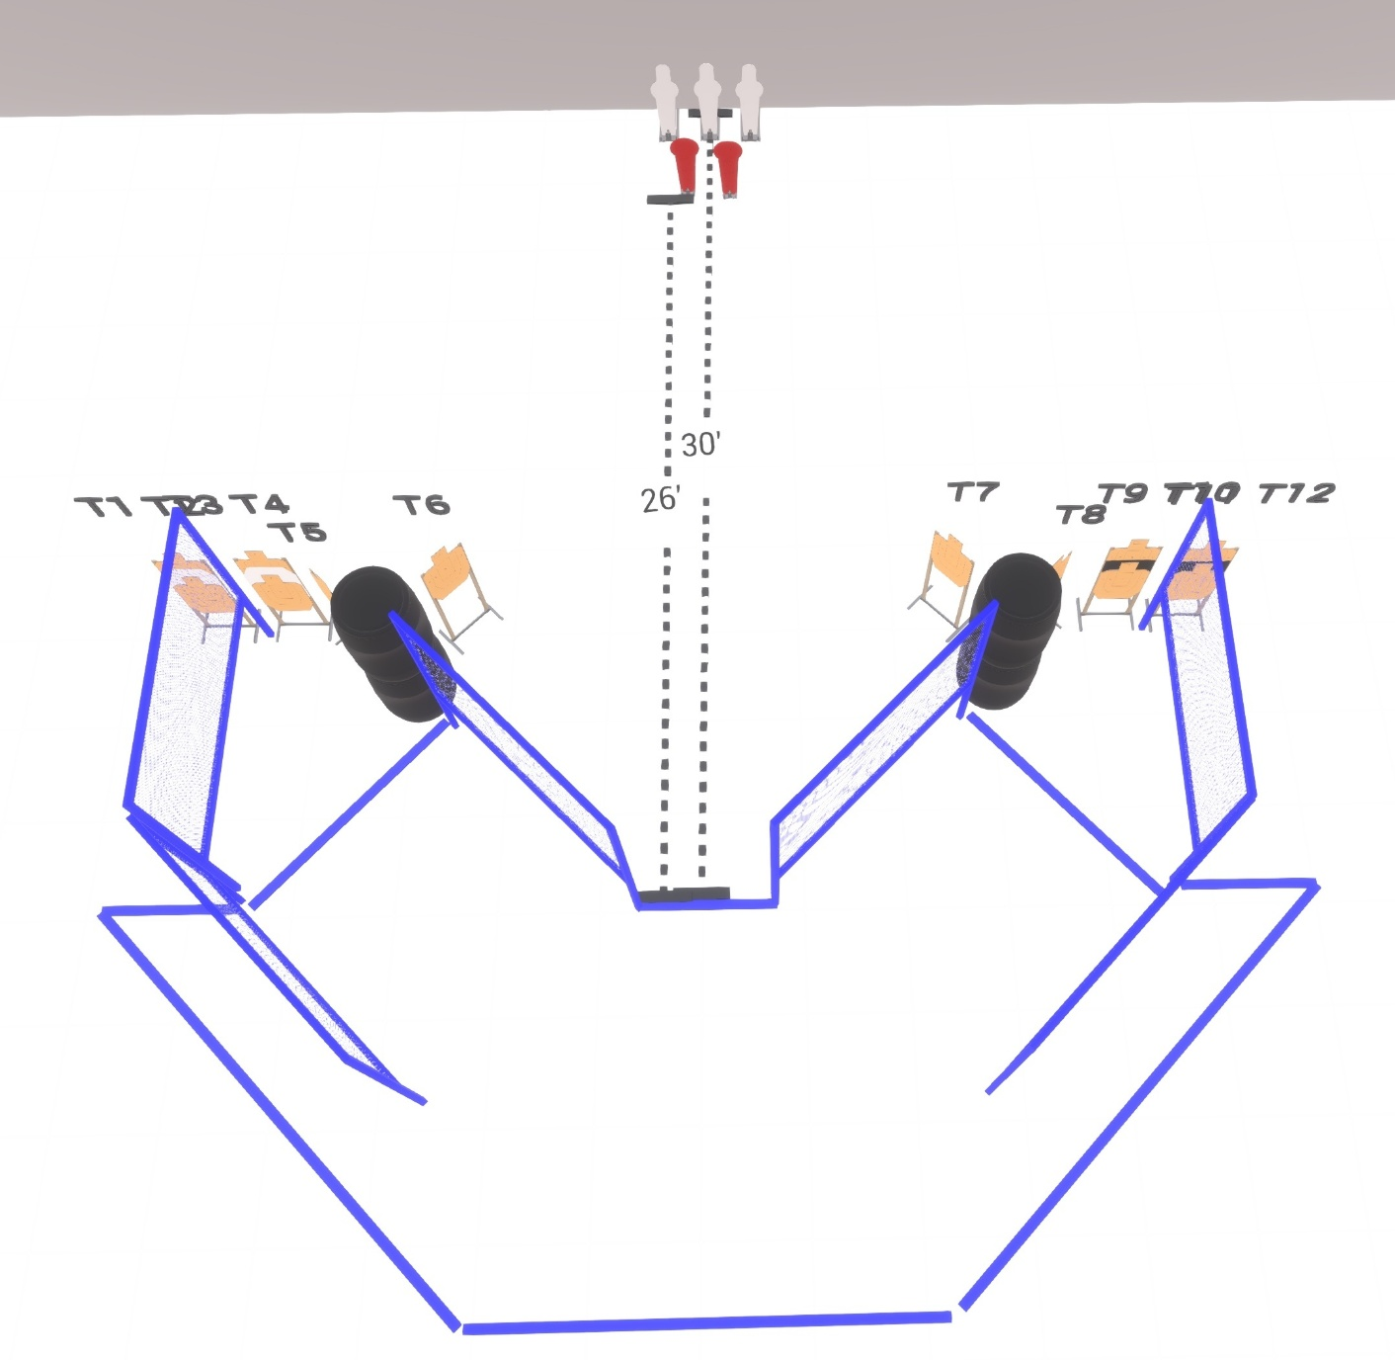

Written Stage Briefing:

Stage 3 – Bonnie Blue - is a 31 round, 155 point, Comstock Course. There are 14 cardboard targets and 3 steel targets.

Starting with Both feet touching the Shooting Sports Innovations Xs.
Handgun is loaded and holstered, wrists below belt.
PCC is loaded held in both hands, stock on belt.

On the audible start signal, engage targets from within the shooting area.

USPSA / NROI Range Commands:
- Make Ready
- Are you ready?
- Standby
- If finished, unload and show clear
- If clear, hammer down and holster (Handgun)
If clear, hammer down and flag (PCC)
If clear, cylinder closed and holster (Revolver)
- Range is clear

Setup Notes:
8 Single Wall Stands
2 Double Wall Stands
6 Full Walls
8 Target stands / 16 target sticks
5 Poppers + bases
2 Starting Xs
4+ Barrels



